**IONS Technical Task**

**Notes to IONs assessment team**

🡪Only Plugin used:

<https://github.com/wp-plugins/horizontal-scrolling-announcement/blob/master/horizontal-scrolling-announcement.php>

*as I have no time to understand php codes and come up with my own plugin codes

🡪The site looks like this:

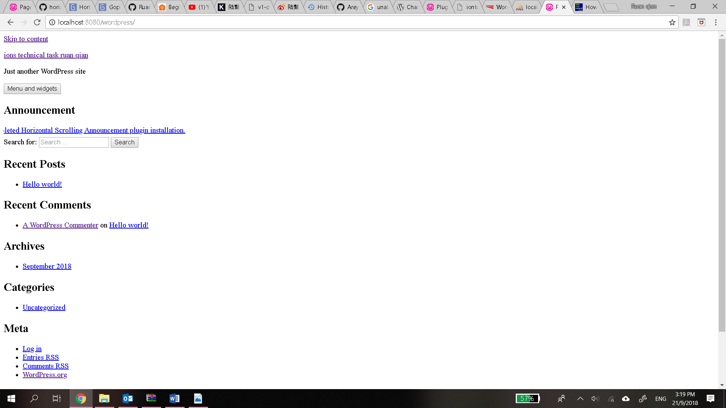

*Yep I messed up, I tried to changed the site URL out of curiosity and upon realising that i don’t own any domain name, I changed back the site URL and this happened. Not sure where I went wrong but CSS seems to have stopped working…

**Reflection:**

Libraries used:   
Various Wordpress guide websites that I didn’t keep track and this physical book called: *Wordpress: The missing manual* by MacDonald Matthew which I borrow from the library.

Learning point:

-Existing mysql and skype on a computer will interfere with the installation of Wampserver  
-It is very important to take note of the port numbers used when installing wordpress.  
-SIM school wifi blocks out everything but not wordpress, so don’t doubt the wifi when the installation process isn’t smooth.  
-Don’t mess around the wp-config.php unless you know what you are doing  
-Learn to make good use of FTP files because every damn guides/solutions on the internet regarding wordpress will point you to utilising FTP folders so that even if you screwed up, things can still be salvaged.  
-The most important thing I have learnt is to manage my time well and not do last minute work.